White Light for Reptiles

Content

Aim of this article 1

Introduction 2

Colour Vision and Photoreceptors of Reptiles 2

Spectral Graphs 3

Colour Coordinates 4

Light Sources Compared 6

Daylight 6

Halogen Lamp and Sunlight at Sunset 6

LED 7

Fluorescent Lamps 8

“Office tubes” 8

Narva BioVital and other fluorescent lamps with UVA phosphor 8

UVB fluorescent lamps 9

Metal Halides 9

Non-UVB metal halides 9

UVB metal halides 10

# Aim of this article

I hope that the reader of this article gets the following main messages:

* Reptile colour vision differs from human colour vision. (Amphibian colour vision is similar to human colour vision, so this text is not valid for amphibians)
* If someone aims to use a light source that is like sunlight, CRI and CCT will not help – CRI and CCT are calculated for human colour vision and are meaningless for reptiles.
* Especially LEDs, even with high CRI and around 6000 K CCT, have an intense and saturated colour from a reptile’s perspective, because they do not emit UVA.
* Using lamps that are white to humans but coloured to reptiles should be an active decision, based on the other advantages of these lamps (UVB, heat, …). It should not be a mistake based on the human perception, to which all lamps emit white light.

All graphs are also found in the reptile lamp database [www.lamps.licht-im-terrarium.de](http://www.lamps.licht-im-terrarium.de) for a large variety of lamps.

# Introduction

Human colour vision is based on the three basic colours red, green and blue. Reptile colour vision however is based on four basic colours: red, green, blue and UVA.

It is often elaborated that the correct correlated colour temperature (CCT, Kelvin) and the correct colour rendering index (CRI) are especially important in reptile husbandry. Presumably, this shows the big desire to use a lamp that is most like sunlight for reptiles and enables best colour vision. Unfortunately, these two values are only valid for human colour vision and meaningless for reptiles. Anyone who wants sunlike light colours should use metal halide lamps or fluorescent lamps with UVA phosphor and keep away from LEDs, no matter what the CRI and CCT are.

One might ask whether this is needed at all: I do not know of any scientific study that investigated whether reptiles are harmed in any way if kept under non-white light. But this is no proof that they are not affected. Colour seems to play an important role in the lives of reptiles. Some have a strikingly colourful and gender-specific coloration. Some lizards change their colouration within a few minutes for communication or during the year to indicate that they are ready to mate. Flowers and fruits eaten by reptiles often have a striking UVA colour pattern that could make them attractive to reptiles. In the past 20 years some German reptile keepers have reported that their animals thrive when replacing standard fluorescent lamps with Narva BioVital lamps. Perhaps this is due to the different colour of these lamps for reptiles.

## Colour Vision and Photoreceptors of Reptiles

Some scientists have explored the colour vision of reptiles. There are two main approaches. The first and perhaps easier approach is to study the retina of reptiles. The photoreceptors send an electrical signal to they brain when they see light. This signal can be measured. The very short summary is: Turtles and lizards have cones responding to UVA, blue, green, and yellow/orange light. Geckos and Snakes have three photoreceptors responding to UVA, blue, and green.

For my calculations I use these photoreceptor sensitivities as estimated averages:  
  
  

* JOSEF AMMERMÜLLER & HELGA KOLB. 1996. Functional Architecture of the Turtle Retina. Progress in Retinal and Eye Research 15.2. 393–433. <https://dx.doi.org/10.1016/1350-9462(96)00009-2>
* JAMES K. BOWMAKER & ELLIS R. LOEW. Oct 2005. The cone photoreceptors and visual pigments of chameleons. Journal of Comparative Physiology A 191.10. 925–932. . <https://dx.doi.org/10.1007/s00359-005-0014-4>
* ELLIS R. LOEW, LEO J. FLEISHMAN, RUSSELL G. FOSTER & IGNACIO PROVENCIO. 2002. Visual pigments and oil droplets in diurnal lizards: a comparative study of Caribbean anoles. Journal of Experimental Biology 205. 927–938.
* ARNOLD J. SILLMAN, V.I. GOVARDOVSKII, P RÖHLICH, J.A. SOUTHARD & ELLIS R. LOEW. 1997. The photoreceptors and visual pigments of the garter snake (Thamnophis sirtalis): a microspectrophotometric, scanning electron microscopic and immunocytochemical study. Journal of Comparative Physiology A 181.2. 89–101. <https://dx.doi.org/10.1007/s003590050096>
* A.J. SILLMAN, J.K. CARVER & E.R. LOEW. 1999. The photoreceptors and visual pigments in the retina of a boid snake, the ball python (Python regius). Journal of Experimental Biology 202.14. 1931–1938.

The second approach is to test the colour vision of reptiles in a behavioural experiment. Some of these experiments just involve training of the reptile, to approach a feeder with a certain colour and then alter colours to test the ability of the reptile to distinguish colours. Others just use an reflex, like the reflex to snap after pray or the automatic motion of the eye as an response to moving objects. These experiments confirm the results from the

* LINA S.V. ROTH & ALMUT KELBER. 2004. Nocturnal colour vision in geckos. Proceedings of the Royal Society of London - Biological Sciences 271.Suppl 6. S485–S487. <https://dx.doi.org/10.1098/rsbl.2004.0227>
* KARIN EVA ARNOLD & CHRISTA NEUMEYER. 1987. Wavelength discrimination in the turtle Pseudemys scripta elegans. Vision Research 27.9. 1501–1511.
* DANIELE PELLITTERI-ROSA, ROBERTO SACCHI, PAOLO GALEOTTI, M. MARCHESI & MAURO FASOLA. 2010. Do Hermann's tortoises (Testudo hermanni) discriminate colours? An experiment with natural and artificial stimuli. Italian Journal of Zoology <https://dx.doi.org/10.1080/11250000903464067>
* ANNE SIMANG, PETER L. CUNNINGHAM & BRIAN T. HENEN. 2010. Color Selection by Juvenile Leopard Tortoises (Stigmochelys pardalis) in Namibia. Journal of Herpetology 44.2. 327–331. . <https://dx.doi.org/10.1670/08-338.1>

## Spectral Graphs

[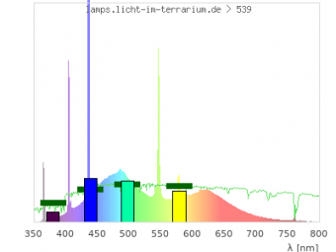](https://translate.googleusercontent.com/translate_c?depth=1&pto=aue&rurl=translate.google.com&sl=auto&sp=nmt4&tl=en&u=http://www.licht-im-terrarium.de/_detail/vis/cones_539.png%3Fid%3Dvis%253Alampen&usg=ALkJrhhJv5YJsNvVUfDU11IbZzYpcwk0xA)For each lamp in the next section I will show a figure with:

1. The spectrum of the lamp measured with a high-resolution spectrometer. The spectrum is shown with the typical rainbow colours in the background.
2. As reference, the spectrum of sunlight, shown as a green line. The solar spectrum is scaled to the same average visible intensity to make the two spectra easier to compare. This is valid because colour is only determined by the shape and not the intensity of the spectrum.

These high-resolution spectra show all physical details, e.g. which molecules are present in the earth's atmosphere and filter the light, or which molecules are present in a discharge lamp, or the primary LED emission in blue and the phosphor(s) that add longer wavelengths. However, this high resolution is often misleading for colour vision. You need a spectrometer with many hundreds or thousands of camera pixels to make the fine lines visible in the spectrum. The reptile eye does not have thousands but only three or four receptors. All the details of the fine lines are invisible to the eye. What is important is how the energy is distributed over a much coarser resolution.

Therefore, the figures also show:

1. The effective irradiance of the lamp’s light towards the four cones of a reptile. These are displayed as coloured bars.
2. The effective irradiance of sunlight towards the four cones of a reptile. These are displayed as thick dark green markers.

If the four coloured bars are close to the four green markers, then the lamp has a similar colour as sunlight.

## Colour Coordinates

The effective irradiances (height of the bars) fully describes the colour that the eye perceives. For human colour vision the colour in software is described by RGB values, which is not exactly the light intensity the three cones in the human eye are detecting, but close. The RGB system is a good way to become familiar with colour coordinates. When the amount of red, green, and blue is the same, the colour is white. Already a little reduction of red makes the resulting colour a blueish white. Reducing the light signal that one of the cones sees to zero results in a very saturated colour.

  

Describing human colour vision with three coordinates (R, G, B) is not the most elegant method, because only the relative ratio describes the colour hue: (250;200;0) is the same colour hue as (0.8*250;0.8*200;0.8*0) = (200;160;0), but with different brightness.

 

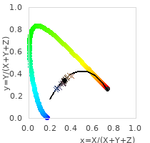It is therefore common in colour science to use only the relative values and and plot these (x,y)-coordinates in a diagram called the “CIE colour triangle”[1]. The colour triangle is also widely used outside science: The colour coordinate of the light source is something lamp manufacturers usually provide together with CCT and CRI. Also, when you buy a TV screen the colours that can be displayed with the screen are indicated in this colour triangle. And photographers and graphic designers are usually familiar not only with the CIE colour triangle but also with other colour models and their colour spaces.

For a reptile with three light receptors it is quite simple to calculate a “3-cone-reptile colour triangle” and indicate the colour position of each light source. For a reptile with four light receptors the colour triangle becomes a colour pyramid, which is more difficult to display, so it is not included here.

Using such colour spaces for animals is established method. It is used for mammals, birds, reptiles, and insects. The colour space is often based on the measured absorbance spectrum of the photoreceptors in the retina (cones or rods). Predictions from the colour space are confirmed by behavioural experiments.

* ALMUT KELBER, MISHA VOROBYEV & DANIEL OSORIO. 2003. Animal colour vision - behavioural tests and physiological concepts. Biological Reviews 78. 81–118. . <https://dx.doi.org/10.1017/S1464793102005985>
* NATASHA R. LEBAS & N. JUSTIN MARSHALL. 2000. The role of colour in signalling and male choice in the agamid lizard Ctenophorus ornatus. Proceedings of the Royal Society of London - Biological Sciences 267.1442. 445–452.
* MANUEL LEAL & LEO J. FLEISHMAN. Feb 2002. Evidence for habitat partitioning based on adaptation to environmental light in a pair of sympatric lizard species. Proceedings of the Royal Society of London - Biological Sciences 269.1489. 351–359. <https://dx.doi.org/10.1098/rspb.2001.1904>

For each light source, the colour triangle of a “three-cone reptile” is shown. Here I compare the colour triangle of human colour vision (top) with the colour triangle of a three-cone-reptile (below). Each graph shows:

1. The coordinates of the spectral colours (light of a single wavelength) that form the outer line as a thick rainbow coloured line. The colour of the line indicates the colour seen by a human observer.
2. 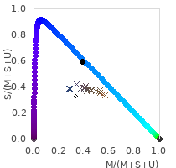The colour coordinates of various phases of daylight as coloured crosses. The colour of the cross indicates the colour of the light seen by a human. For human colour vision the daylight colours lie around the parabola that shows the colour coordinates of all black body radiators of different CCT. The reddish crosses of sunlight with lower CCT early or late in the day are towards the right. The blueish crosses of daylight in the shade or on overcast days with higher CCT are towards the left.  
   For the reptile the order is less well preserved, but still the reddish crosses tend to be more towards the right and the blueish crosses more to the left. But the different phases of daylight still lie on a parabola like area.
3. The coordinate of the lamp or light source as a thick black circle.  
   In this example the colour coordinate of the light source lies within the area of the daylight colour coordinates. This is the case for almost all light sources because their spectrum is optimized for human colour vision.  
   The colour coordinate of this light source happens to lie far outside the area of the daylight colour coordinates for reptile colour vision.

These spectra of different phases of daylight were used:

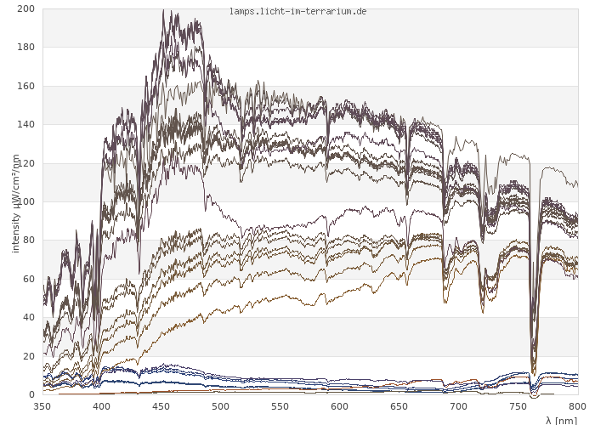

# Light Sources Compared

## Daylight

Sunlight around midday is balanced with roughly the same amount of red, green and blue and roughly half the amount of UVA. The graph shows my reference spectrum, so the dark-green markers lie exactly at the top of the coloured bars.

[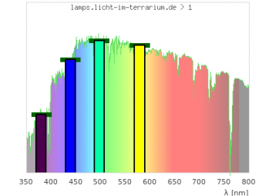](https://translate.googleusercontent.com/translate_c?depth=1&pto=aue&rurl=translate.google.com&sl=auto&sp=nmt4&tl=en&u=http://www.licht-im-terrarium.de/_detail/vis/cones_1.png%3Fid%3Dvis%253Alampen&usg=ALkJrhgNNkkTDZ0WyIoxkJ4jV4KYJxEmLg)  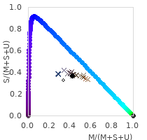

## Halogen Lamp and Sunlight at Sunset

Halogen incandescent lamps have a strong decrease of the intensity from red to UVA. There is still some UVA left in the spectrum that is seen by the UVA receptor. This is similar to sunlight around sunset. However, the halogen lamp is still a bit more reddish (less UVA, more red) than sunlight at sunset. The colour coordinate of the halogen lamp lies a bit outside the area of phases of natural sunlight and further towards the colour coordinate of 480 nm spectral light (cyan to humans).

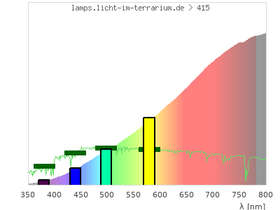 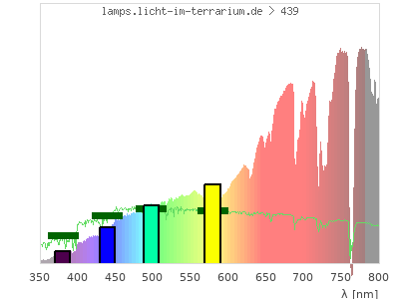  
 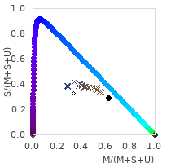 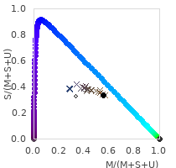

## LED

LEDs offer a lot of control over the composition of the spectrum, so there is a big variety in the spectrums of LEDs. But all white LEDs have in common that they do not emit infrared or UV. The spectrum usually starts around 420 nm (blue) and ends at around 700 nm (orange/red). For the human eye this light is white and the colour temperature can range from 2700 K to 6500 K with CRIs well above 90 when the spectrum has no gaps.

From a reptile’s perspective, the picture is different! The effective irradiances for the blue, green and red cones are like hat for sunlight. But the UVA cone does not see light because LEDs do not emit UVA.

[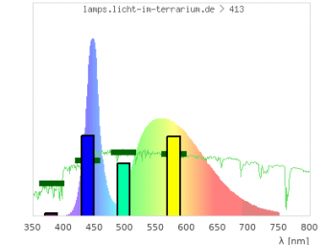](https://translate.googleusercontent.com/translate_c?depth=1&pto=aue&rurl=translate.google.com&sl=auto&sp=nmt4&tl=en&u=http://www.licht-im-terrarium.de/_detail/vis/cones_413.png%3Fid%3Dvis%253Alampen&usg=ALkJrhhx-MlAuEOgu4rJ6VOYd7AtoMuZAA) [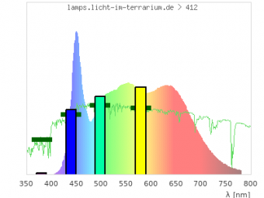](https://translate.googleusercontent.com/translate_c?depth=1&pto=aue&rurl=translate.google.com&sl=auto&sp=nmt4&tl=en&u=http://www.licht-im-terrarium.de/_detail/vis/cones_412.png%3Fid%3Dvis%253Alampen&usg=ALkJrhiFvC4G_3nXts-lZQzjuJbpq42mDQ)  
  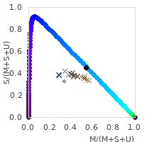

If the LED also had UVA it would be white for reptiles. But it ONLY lacks UVA, so it has the complementary colour to UVA. Complementary colours to primary colours usually produce a very strong colour impression. Example for human vision: Light is white when the red, green and blue cone get almost the same amount of light. If the green cone does not see light, the colour is the complementary colour to green: pink. This is the case for plant-LEDs that only emit red and blue but not green. These lamps have strong pink colour. These plant-LEDs are probably the best guess of what white LEDs look to reptiles. LEDs will not seem something like “slightly different colour temperature” or “slight colour cast” towards reptile but strongly coloured. This is also indicated by the colour coordinate: The colour coordinate of the lamp lies directly on the outer line formed by the spectral colours. The colour coordinate lies exactly at the colour coordinate of light with 450 nm – 490 nm wavelength (cyan to humans).

If you want to use LEDs, even if in addition to other, white, lamps, you should always ask yourself if you would do that if the LED was pink. It is so misleading that these lamps look wonderfully white to us humans.

## Fluorescent Lamps

### “Office tubes”

The typical office fluorescent lamps with colour codes 830 – 860 and 930 – 930 have no UV phosphor. However, the mercury produces radiation at 365 nm and 405 nm. This ensures that the UVA cones sees at least some light. Still, the colour coordinate lies outside the range of natural sunlight. But the lamps are probably at least whitish for reptiles.

[](https://translate.googleusercontent.com/translate_c?depth=1&pto=aue&rurl=translate.google.com&sl=auto&sp=nmt4&tl=en&u=http://www.licht-im-terrarium.de/_detail/vis/cones_539.png%3Fid%3Dvis%253Alampen&usg=ALkJrhhJv5YJsNvVUfDU11IbZzYpcwk0xA) [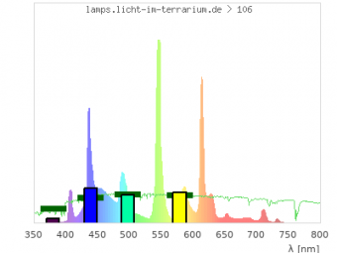](https://translate.googleusercontent.com/translate_c?depth=1&pto=aue&rurl=translate.google.com&sl=auto&sp=nmt4&tl=en&u=http://www.licht-im-terrarium.de/_detail/vis/cones_106.png%3Fid%3Dvis%253Alampen&usg=ALkJrhhTQIruv-YXfNDrKRF-1P-SstkKQw)  
 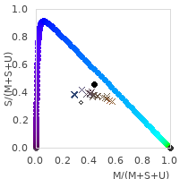 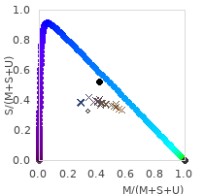

### Narva BioVital and other fluorescent lamps with UVA phosphor

Better than office tubes are special fluorescent lamps with an UVA phosphor. For reptiles, their colour is remarkably close to sunlight. The colour coordinate is almost within the range of natural sunlight.  
In Germany lamps are available from <https://www.natur-nah.de/shop/beleuchtung/leuchtstofflampen/>, also good seem to be <https://www.true-light.eu/>

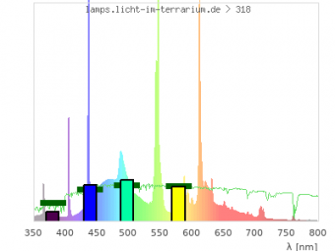  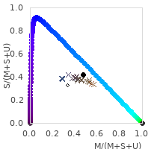

### UVB fluorescent lamps

UVB fluorescent lamps can also have a very balanced spectrum. Depending on the wavelength up to which a reptile can see into the UV, it might be that the UV cone sees too much light and the colour of the lamp has a UV colour cast.

[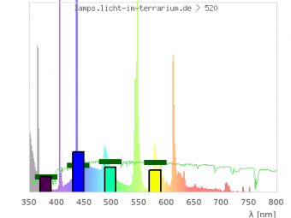](https://translate.googleusercontent.com/translate_c?depth=1&pto=aue&rurl=translate.google.com&sl=auto&sp=nmt4&tl=en&u=http://www.licht-im-terrarium.de/_detail/vis/cones_520.png%3Fid%3Dvis%253Alampen&usg=ALkJrhiLqxageTf4KjZyFUCbcf9dhW_m2A)  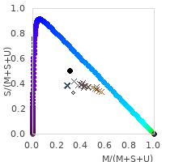

## Metal Halides

### Non-UVB metal halides

These lamps developed for retail lighting have a very sunlike spectrum. The Osram Powerball HCI 940 in the left is very sunlike. The Osram HQI on the right shows that the quartz burner has a slightly less balanced spectrum. From human vision perspective and lifetime, ceramic burners are superior. But from reptile colour vision, I do not see large differences. For both lamps the colour coordinates lie in the range of natural sunlight.

[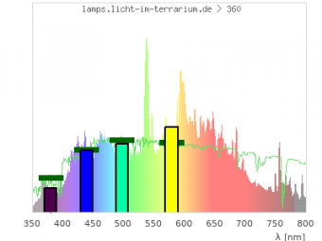](https://translate.googleusercontent.com/translate_c?depth=1&pto=aue&rurl=translate.google.com&sl=auto&sp=nmt4&tl=en&u=http://www.licht-im-terrarium.de/_detail/vis/cones_360.png%3Fid%3Dvis%253Alampen&usg=ALkJrhjnfDW84sLC8XXTvapc43Zub9h1KQ) [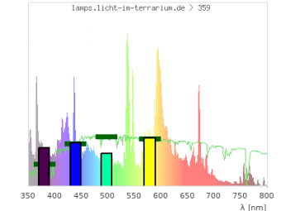](https://translate.googleusercontent.com/translate_c?depth=1&pto=aue&rurl=translate.google.com&sl=auto&sp=nmt4&tl=en&u=http://www.licht-im-terrarium.de/_detail/vis/cones_359.png%3Fid%3Dvis%253Alampen&usg=ALkJrhiaeCBe0zOlcPHlz0g3_Y8zQov-Xw)  
 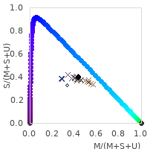 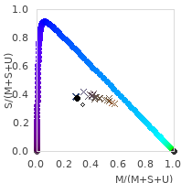

The Iwasaki Eye Colour has a particularly sun-like spectrum with an impressive colour rendering index of 96. From a reptile’s perspective, I do not see a clear difference to the other metal halides.

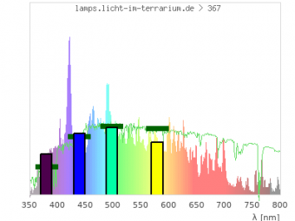 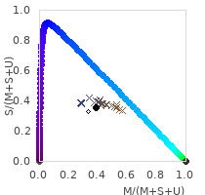

### UVB metal halides

UVB metal halides (Lucky Reptile Bright Sun and others) do not emit the same sunlike spectrum. The spectrum consists of more individual lines, which is not necessarily negative for colour vision, because the eye cannot see the individual lines. Their disadvantage is the too strong UVA emission which gives the light a strong UVA colour cast. The colour coordinate lies outside the range of natural sunlight.

[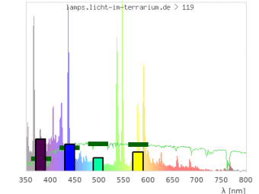](https://translate.googleusercontent.com/translate_c?depth=1&pto=aue&rurl=translate.google.com&sl=auto&sp=nmt4&tl=en&u=http://www.licht-im-terrarium.de/_detail/vis/cones_119.png%3Fid%3Dvis%253Alampen&usg=ALkJrhjP7OZtr0EQEaGQUw3RX0nGBGDhfQ) [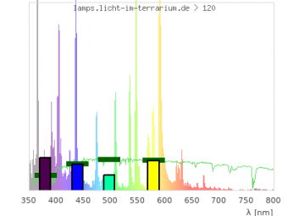](https://translate.googleusercontent.com/translate_c?depth=1&pto=aue&rurl=translate.google.com&sl=auto&sp=nmt4&tl=en&u=http://www.licht-im-terrarium.de/_detail/vis/cones_120.png%3Fid%3Dvis%253Alampen&usg=ALkJrhhkzOYf4gC530M9zdaN50ijXZ6idQ)  
 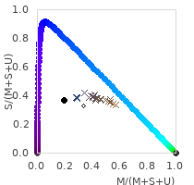 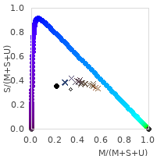

## Self-ballasted mercury vapour lamps

These lamps are luckily fading out from use. Lifetime, brightness, reliability, and safety of metal halide lamps is much bigger. Also, their colour is a bit further towards UVA than UVB-metal halides.

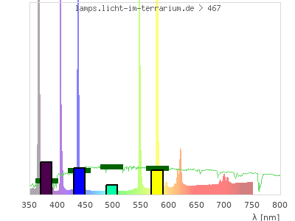 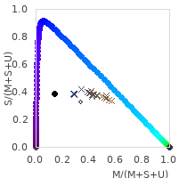

Dr. Sarina Wunderlich  
www.licht-im-terrarium.de

1. To be correct, not R,G,B but X,Y,Z are used in this formula, however X,Y,Z are related to R,G,B.